Roll no :- 71

Name :- NARKHEDE LOCHANA SANJAY

Assignment No :- 1.1

Assignment :- Develop programs to understand the control structures of python

(conditional statements).

If statement :-

a = int(input("Enter 1st Number: "))  
b = int(input("Enter 2nd Number: "))  
  
if(a > b):  
 print(a, "is greater than ",b)

Output:-

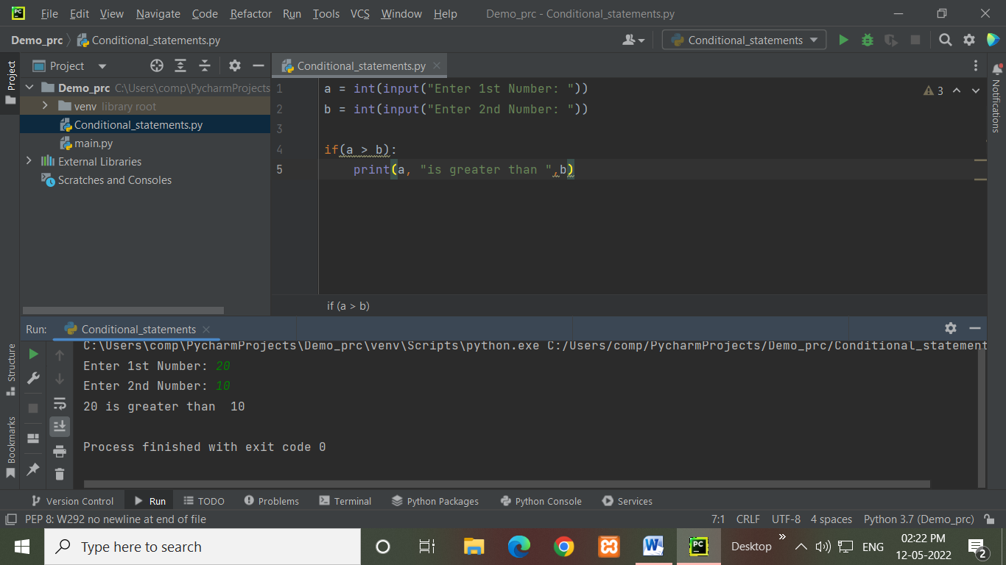

If…else statement :-

a = int(input("Enter 1st Number :"))  
b = int(input("Enter 2st Number :"))  
  
if a > b:  
 print(a,"is greater than",b)  
else:  
 print(a,"is NOT greater than",b)

Output :-

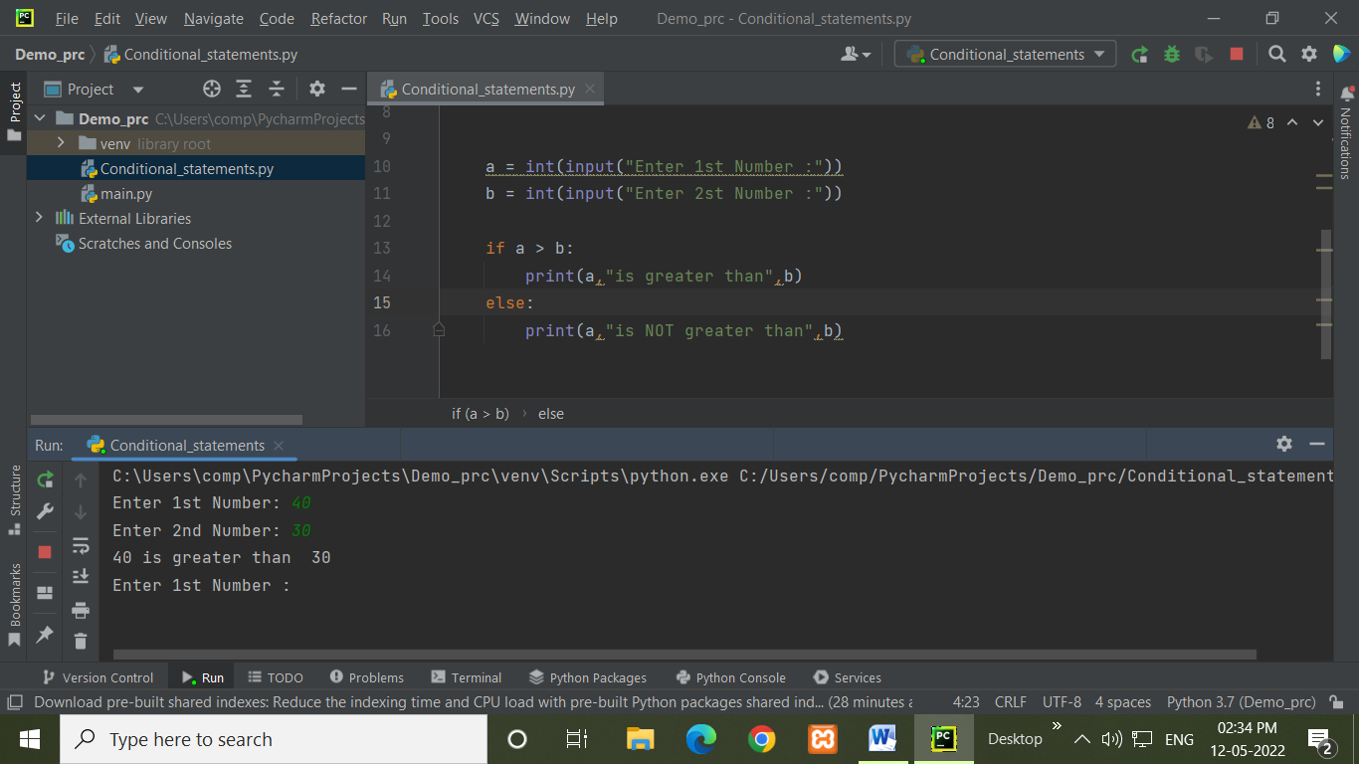

elif statement :-

a = int(input("Enter 1st Number :"))  
b = int(input("Enter 2st Number :"))  
  
if a > b:  
 print(a,"is greater than",b)  
elif a < b:  
 print(a,"is less than",b)  
else:  
 print("Both are equal")

Output :-

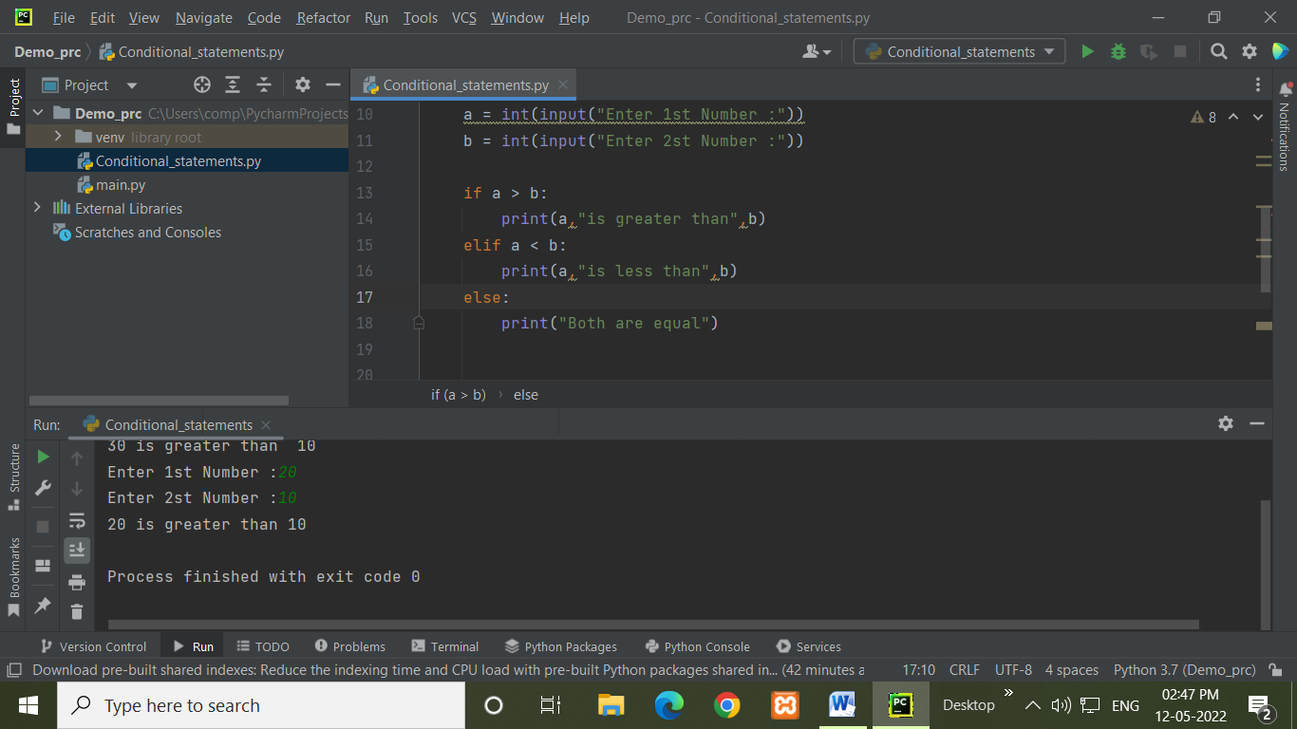

Nested if-statement :-

a = int(input("Enter any number :-"))  
if a >= 0:  
 if a == 0:  
 print("zero")  
 else:  
 print("positive number")  
else:  
 print("negative number")

Output :-

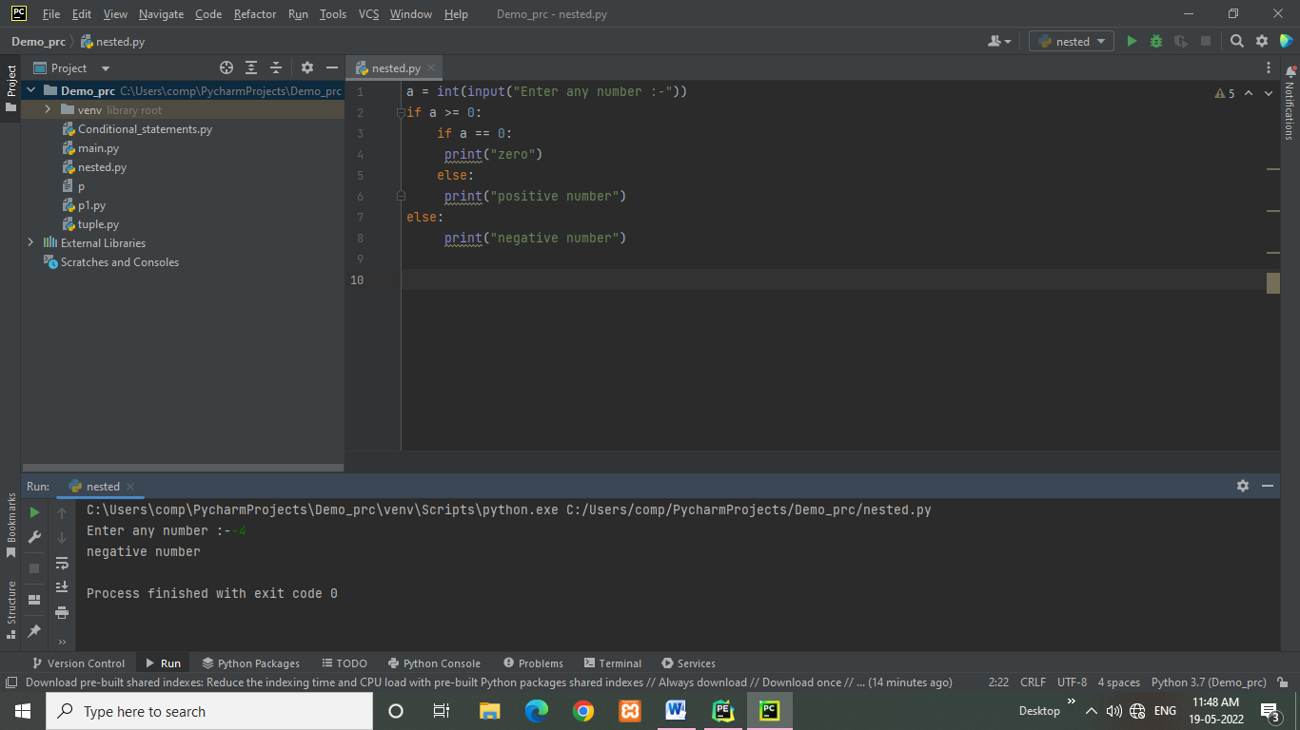

Ladder if….else :-

Marks = float(input("Enter the marks of student: "))  
if Marks > 85:  
 print("The Grade of student is A+")  
elif Marks > 75:  
 print("The Grade of student is A")  
elif Marks > 65:  
 print("The Grade of student is B+")  
elif Marks > 55:  
 print("The Grade of student is C")  
elif Marks > 45:  
 print("The Grade of student is p")  
else:  
 print("The Grade of student is F")

Output :-

